# Rate Book

Architectural Design

1. **Introduction and Context**
2. ***Project*** *–An application to provide rating to miscellaneous mundane things.*
3. ***Aim*** *- This web-application will let people rate everything/anything possible. Ex: Universities, Professors, Food, Products, Cities, courses, services and even people. Like Quora lets people ask any Question/Query and other people give their opinions, similarly this web-app will let people rate and share their experiences with anything they want.*
4. **Users and their Goals**

***Project*** *–An application to provide rating to miscellaneous mundane things.*

***Aim*** *- This web-application will let people rate everything/anything possible. Ex: Universities, Professors, Food, Products, Cities, courses, services and even people. Like Quora lets people ask any Question/Query and other people give their opinions, similarly this web-app will let people rate and share their experiences with anything they want.*

**Actors and their Goals**

***Actors****:*

* *End Users*

***Goals****:*

* 1. ***Log in*** *- Users will have to login to rate something.*
  2. ***Rate Something*** *- Registered users will rate something they bought or got to know about.*
  3. ***Search rating category*** *- Users can search a category of product to want to know about or share their views about.*
  4. ***Leave Reviews*** *- Only registered users can leave reviews and rate an item.*
  5. ***View Reviews*** *- All the web users can view reviews and rating about anything.*
  6. ***Sign Up*** *- New web users can sign up if they want to rate anything and share their experiences about an item.*

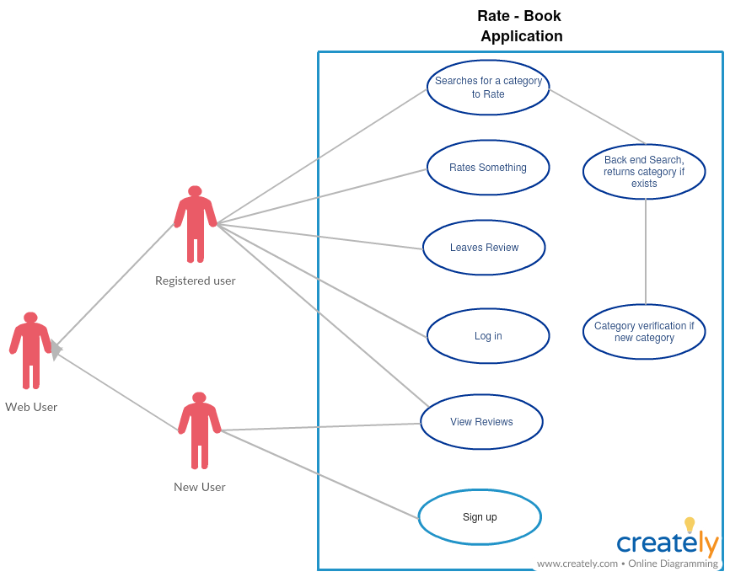

1. **Major Components and Their Relationship**

*Message – 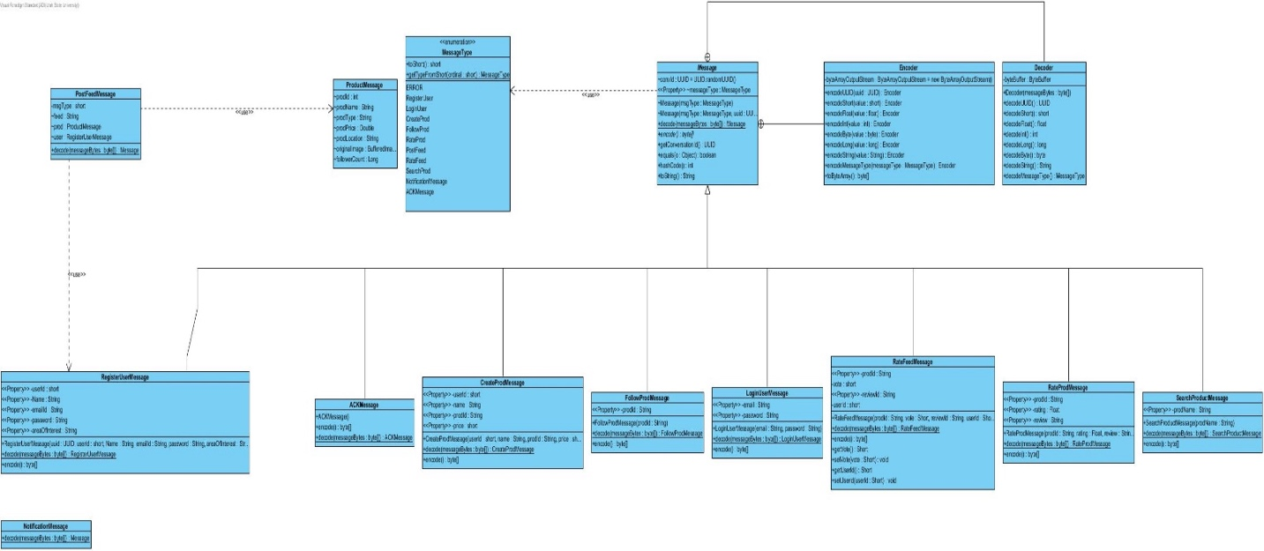*

*Comm Sub System –*

